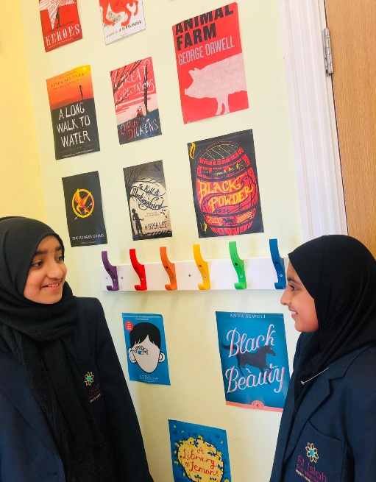
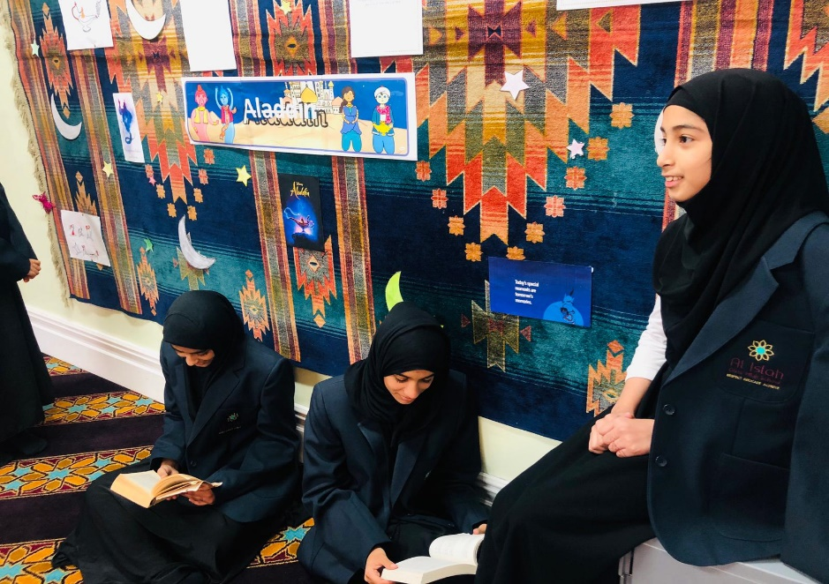
Year 9
Curriculum Information
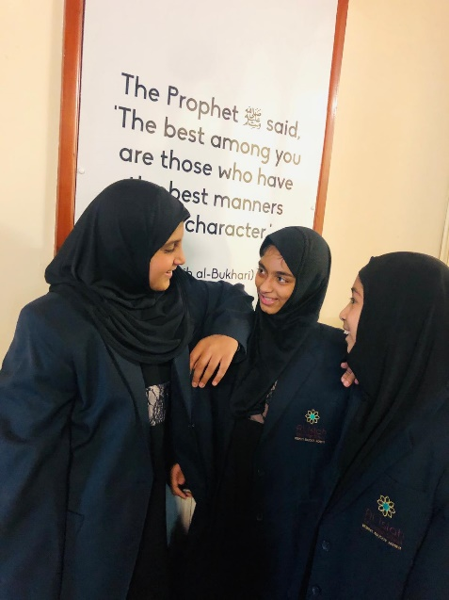

Contents

- Welcome from the Headteacher

- The School Day Routine

- Aims of the year 9 curriculum

- Subjects Studied

- Target Setting

- Curriculum Overview

- Super Enrichment PSHE Days

- Support for Parents

- Feedback

Welcome from the Headteacher
Welcome to Al Islah Girls High School, a thriving community that places the best interests of young people at the heart of everything we do. All students are challenged and supported to Respect, Educate and Achieve.
We are a small independent secondary school situated in Blackburn, focusing primarily on providing a secular education since 1995 in an atmosphere encouraging Islamic Values.
At Al Islah everyone is committed to providing the best educational experiences and opportunities for our pupils. At the heart of the school’s work is a commitment to high quality teaching and learning and achievement for all: for our students to be safe, happy and successful developing as individuals into caring, responsible citizens who participate fully in school life and are proud of their achievements. Every student at Al Islah is encouraged to have ambitious goals and everybody is responsible for creating a culture of high expectations and academic excellence.
We are proud of our achievements – our examination success, our extra-curricular programme, our charity work and our community involvement. We are committed to the pursuit of outstanding teaching and learning alongside the highest possible academic, personal and moral standards. This commitment is built upon a shared belief in hard work, self-reflection and a culture of respect and support for others.
This booklet has been produced to provide you with information about your child’s learning at Al Islah Girls High School. This booklet is intended to share with parents the main aims of the curriculum and learning opportunities at school. I hope that you will find it useful and informative. I would welcome feedback and suggestions as to how it may be developed in future years.

Apa Nikhat

Headteacher

The School Day Routine

Tuesday, Wednesday &Thursday

8.00am | Breakfast Club
8.20am | Arrive at school and go to your registration room
8.30am | Registration and Tutor time
8.45am | Period 1
9.45am | BREAK
10.00am | Period 2
11.00am | Period 3
12.00pm | LUNCH  (Zohar Salaah)
12.45pm | Period 4
1.45pm | Period 5
2.45pm | END OF SCHOOL

Monday and Friday

8.00am | Breakfast Club
8.20am | Arrive at school and go to your registration room
8.30am | Registration and Assembly  (Monday – Recitation of Surah Yaseen, Friday – Recitation of Surah Kahf)
9.00am | Period 1
9.45am | BREAK
10.00am | Period 2
11.00am | Period 3
12.00pm | LUNCH  (Zohar Salaah)
12.45pm | Period 4
1.45pm | Period 5
2.45pm | END OF SCHOOL

Aims of the Year 9 curriculum

Successful Transition
The Year 9 curriculum at Al Islah Girls High School is designed to ensure a successful transition from KS3 to KS4 studies. We pride ourselves on the success of our Pastoral Team in ensuring our year 9 students are challenged and supported to “Respect, Educate and Achieve” from the very start of their journey at Al Islah.

Confidence building and independent learning
We aim to support your child in becoming a confident learner through a well-rounded educational experience that extends well beyond the classroom). We encourage parents to support their children in home study. Homework is a key part of students’ learning, encouraging them to be independent and contributing to the quality of learning in school.

We encourage students at Al Islah to be involved in our extensive charity work, participate in educational visits and work in partnership with local schools and colleges. Student leadership is a key aspect of life at Al Islah through the Student Council, PE and the school librarians, reading mentors and students leading assemblies. There are many opportunities for your child to be involved in extracurricular activities which will help them to gain in confidence and work with others.

Specific development of numeracy and literacy
There is a strong focus for Year 9 students on reading skills through the set reading materials for the GCSE English Literature resources and access to the library. The huge success of our mathematics department has established a culture of high expectations and excellent pupil attainment and progress.

Academic Transition from Key stage 3 to key stage 4
There is a clear focus on academic transition from key stage three to key stage four.

Wellbeing
Year 9 have five super learning days during the school year which provide opportunities for students to develop an awareness of and respect for themselves and others. This is further developed in lessons such as RS, Citizenship and science and also during the school assemblies.
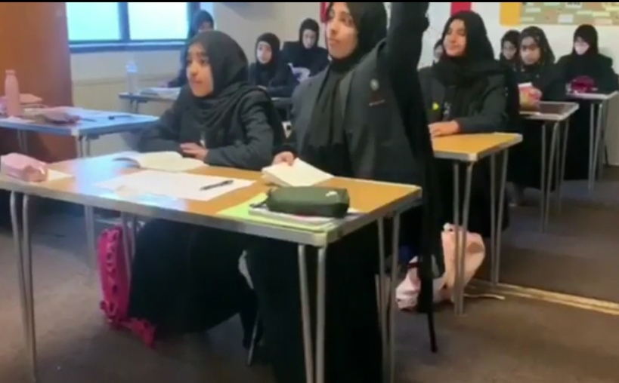

Homework
We are very grateful to parents and carers who check and monitor the home learning of pupils. We provide each child with an academic planner in which they can record homework, targets and attendance. Parents can check this each day so that they are aware of homework that has been set in school. Please see the guidance on homework below.

It is important that, as parents, you encourage your child to complete any homework set in school. Homework teaches your child to work independently whilst allowing them to review and practice work that has been covered in class. It helps your child develop positive study skills that will serve him or her well throughout life.

At Al Islah we recommend that year 7 students are given up to 30 minutes of homework per subject, per week.

Homework Timetable for year 9
 | Year Group |  |  | Monday | Tuesday |  |  | Wednesday |  | Thursday |  | Friday
 |  | English  9  Maths |  |  | Maths |  |  | English Maths  English
 | Subject |  |  | Year Group(s) |  | Homework Information
 | Science |  |  | Y7/8 |  | Once/twice per week
Citizenship |  |  | Y7/8 |  |  |  | Once per week
Urdu |  |  | Y7/8 |  |  |  | Once/twice per week
History |  |  | Y7/8 |  |  |  | Once/twice per week
IT |  |  | Y7/8 |  |  |  | Once/twice per week
RS |  |  | Y7/8 |  |  |  | Once/twice per week
Tarbiyah Y7/8 Once per week

Subjects Studied

Subject | Lessons per week
Mathematics | 4 x 1 hour lessons
English | 4 x 1 hour lessons
Science | 4 x 1 hour lesson
Religious Studies | 2 x 1 hour lessons
History | 2 x 1 hour lessons
PE | 2 x 1 hour lessons
Citizenship | 2 x 1 hour lessons
Urdu | 2 x 1 hour lessons
ICT | 2 x 1 hour lessons
Tarbiyah & PSHE | 1 x 1 hour lesson

Target Setting
Target setting for students is based on knowledge about expected rates of progress and data for each individual child. Teachers monitor progress carefully against these targets and plan lessons accordingly to ensure sufficient progress for all students regardless of their starting points in school.
Written and verbal feedback should usually include comments about what a student has done well and what they need to consider in order to make good progress. Parents are informed of progress against their child’s targets in our termly school reports. It is important to remember that children will progress at different rates and a huge range of factors influence this rate of progress.
Subject teachers review student targets regularly. If a student is making excellent progress, the target will be revised upwards. When pupils do not meet their target in a number of subjects we need to explore the reasons why. There are a range of support strategies that we will employ to try to ensure individual pupils make good progress, and it is in these circumstances that the partnership between parents and school is most important.
At Al Islah Girls High School we work hard with all students and set challenging targets that will motivate etc. Each year, the proportion of students achieving the threshold 4+ in English and mathematics has been above the previous years national average. This shows that students at Al Islah make excellent progress.
Every student at Al Islah is encouraged to have ambitious goals and we remain committed to the pursuit of outstanding teaching and learning alongside the highest possible academic standards.

Curriculum Overview: Year 9

Curriculum Overview

Year 7
Subject | Autumn 1 | Autumn 2 | Spring 1 | Spring 2 | Summer 1 | Summer 2
English
Maths | Whole numbers and decimals  Measures, Perimeter & Area  Expressions & formulae | Fractions, decimals & percentages  Angles and 2D shapes  Graphs | Graphs  Decimal calculations  Statistics | Transformations and scale  Equations  Powers and Roots | Constructions and Pythagoras  Sequences  3D shapes  Geometry  Ratio and Proportion  Fractions and Proportion | Probability
Science | Biology  1)  Cell structure  Cell division  Transport in cells  Animals tissues, organs and organ systems | Plant tissues, organs and organ systems  Infection and response  Monoclonal antibodies  Plant disease | Photosynthesis  Respiration  The human nervous system  Biology 1 revision | Hormonal coordination in humans  Plant hormones  Reproduction  Variations | The development of understanding of genetics and evolution  Classification of living organisms  Adaptation, interdependence and competition  Organisation of an Ecosystem | Biodiversity and the effect of human interaction and Ecosystems  Trophic levels in an Ecosystems  Food production  Biology 2 revision
RS
ICT
History | British Empire  Life of Gandhi  The Indian Independence Movement | Gandhi and Congress  The Satyagraha Movement  World War 1 | Introduction to GCSE History topics  Paper 2: Shaping the nation (Section B British depth studies including the historic environment - BA Norman England, c1066-c1100)  Part 1: The Normans: conquest and control | Paper 2: Shaping the nation (BA Norman England, c1066-c1100)  Part 2: Life under the Normans | Paper 2: Shaping the nation (BA Norman England, c1066-c1100)  Part 3: The Norman Church and monasticism | Paper 2: Shaping the nation (BA Norman England, c1066-c1100)  Past paper questions and exam practice
Citizenship | Theme 1: Life in Modern Britain  What are the principles and values that underpin British society?  Key principles and values underpinning British society: Democracy, rule of law, individual liberty, tolerance of faith and beliefs, participation in community.  Exploring multiculturalism and equality.  Key factors that create individual, group, national and global identities.  What do we mean by identity?  Changes and movement of population over time and the impact on communities in the UK, the nature of immigrants and migration to and from the UK.  Diversity in society and the need for mutual respect and understanding.  The values of a democratic society. | What is the role of the media and free press?  The rights and responsibilities and role of the media and a free press in informing and influencing public opinion, in providing a forum for the communication and exchange of ideas and opinions, holding those in power to account.  The right of the media to investigate and report on issues of public interest subject to the need for accuracy and respect for people’s privacy and dignity.  Press regulation and examples where censorship is used. | What is the UK’s role in the key international organisations?  The UK’s role within UN, NATO, EU, the Council of Europe, the Commonwealth and the WTO.  The UK’s membership of the EU and its impact on the UK.  How the UK assists in resolving international disputes and conflicts.  How NGO’s respond to humanitarian crisis.  How can citizens make their voice heard and make a difference in society?  The opportunities and barriers to citizen participation in democracy.  The range of actions a citizen can take who wishes to hold those in power to account.  The role of organisations in providing a voice and support for different groups in society.  How those who wish to bring about change use the media. | Theme 2: Rights and Responsibilities  What laws does a society require and why?  The fundamental principles of law to ensure rights and freedoms, presumption of innocence and equality.  What are a citizen’s rights and responsibilities within the legal system?  The operation of the justice system: police, judiciary, legal representatives, courts, tribunals and other means of dispute resolution.  Rights and legal entitlements of citizens.  The differing legal systems within the UK. | How has the law developed over time, and how does the law protect the citizen and deal with criminals?  How rights have changed and developed over time, from Magna Carta to Human Rights Act.  Nature of criminality.  How we deal with those that commit crime.  What are the universal human rights and how do we protect them?  The importance of key international agreement and treaties in regard to human rights.  The role of international law in conflict situations: to protect victims of conflict, how international humanitarian law helps establish the rules of war | How do citizens play a part to bring about change in the legal system?  The roles undertaken by citizens within the legal system and how the role of the citizen has been seen to be pivotal to our justice system. The responsibilities and roles of citizens in the legal system; as a juror, witness, a victim of crime, magistrate, special constable, police commissioner or member of a tribunal hearing.  The role of a variety of organisations in providing a voice and support for different groups in society campaigning to bring about a legal change or to fight an injustice.  The different forms of democratic and citizenship actions people can take to bring about change and hold those in positions of power to account in regard to issues relating to human rights and the justice system.
Urdu | Revision of the few topics; My house, daily routine and time in Urdu.  Hobbies and future ambitions in Urdu  Speaking assessment  Past exam papers | Parts of speech, shopping, role plays in Urdu.  Weather  Posters work  Essay writing in Urdu  1st mock exam | Restaurant and comprehension regarding restaurant in Urdu.  Healthy and unhealthy lifestyle in Urdu.  Health related professions in Urdu  Past exam papers | Travel and transport in Urdu.  Different cities, culture and different occasions in Pakistan.  All about Britain festivals and culture in Urdu.  Essay and letter writing in Urdu. | Past exam papers  Idioms.  Revision of the certain topics.  GCSE Examination begins.
Tarbiyah & PSHE | Islamic months, Pillars of Islam, The Importance of Quraan and Hadith | Tuhfatul Banaat,Balancing Deen and Dunya, Seerah of the Prophet (SAW), The Hourney of Mi’raaj | Tuhfatul Banaat, wudhu, namaaz | Janazah, Ramadhan, Modesty | The Hereafter, Battles in Islam, Stories of the Prophet, Umrah, Eid-ul-Fitr | Hajj, Social Media, Miracles in Islam, Eid-ul-Adhaa

Super Enrichment PSHE Days

At Al Islah Girls High School, all year 7 students will take part in Super Enrichment PSHE Days. These are whole days when students are taken off their traditional timetable and given deep learning opportunities.

Aims of Super Enrichment PSHE Days at Al Islah Girls High School
The aim of SEDs are to provide opportunities for students to develop in line with the values of Al Islah Girls High School: Respect, Educate and Achieve. In practice this means:
- There are opportunities for students to develop an awareness of, and respect for, themselves and others throughout our Super Enrichment PSHE Day. It aids the development of positive self-esteem, which will help pupils to cope with the challenges of personal growth. It enables students to be aware of the personal choices they can make and prepares them to make responsible decisions. It is about exploring feelings and emotions and enjoying confidence in one’s own ability.
- We provide chances for students to explore and question their own thoughts and feelings. This is enhanced further through our PREVENT days which are in line with the 2015 revised Prevent non-statutory policy. As a school we work in partnership with Blackburn with Darwen Local Authority who deliver sessions not only to pupils but to staff.
- We give students the opportunity to engage with employers and further education providers to ensure future generations will benefit from quality, meaningful interactions that help them understand the links between courses, skills and the pathways they open up.

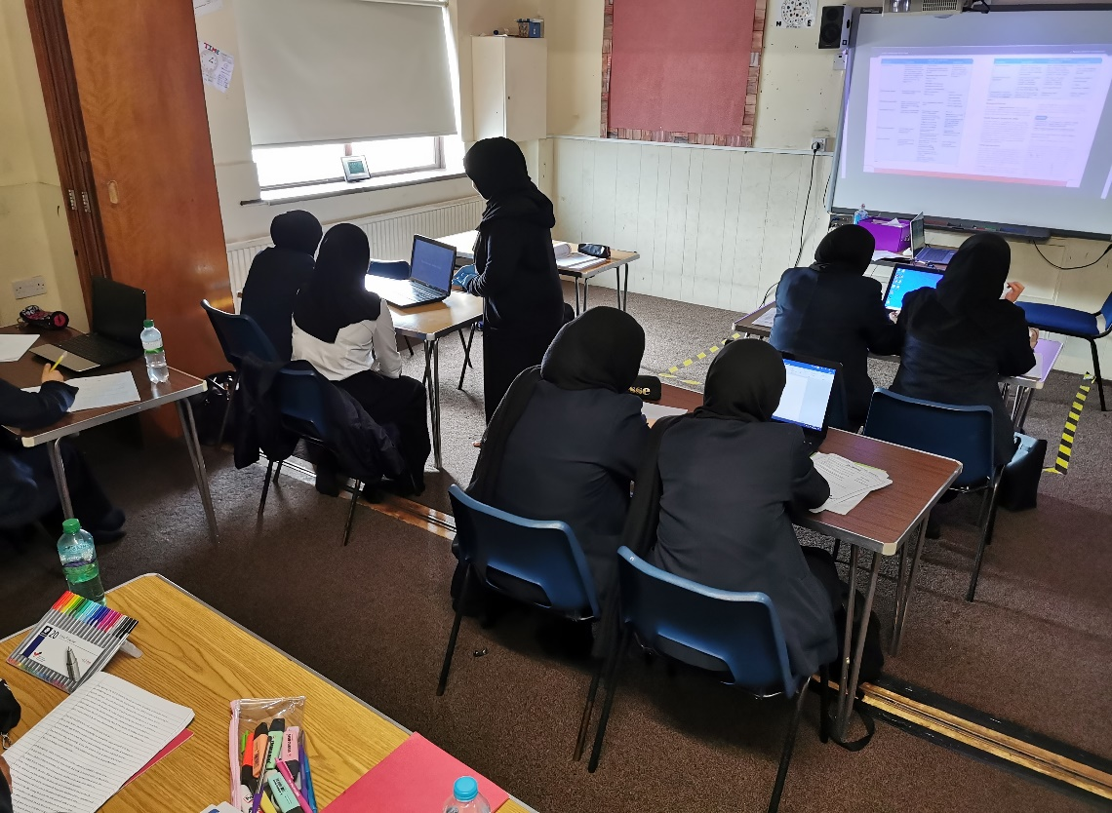

Support for parents

At Al Islah Girls High School we understand how important it is to ensure that Parents can be provided with all the information they need to help their children with their learning and development.
We run a range of support programmes for parents throughout the school year, including additional maths support sessions to help parents to get to grips with key skills within the maths curriculum in order to support their child’s learning. Other events such as coffee mornings and parent feedback sessions also take place throughout the year and we would welcome and encourage parents to be involved in these events.

Feedback

We hope that you have found this booklet informative.
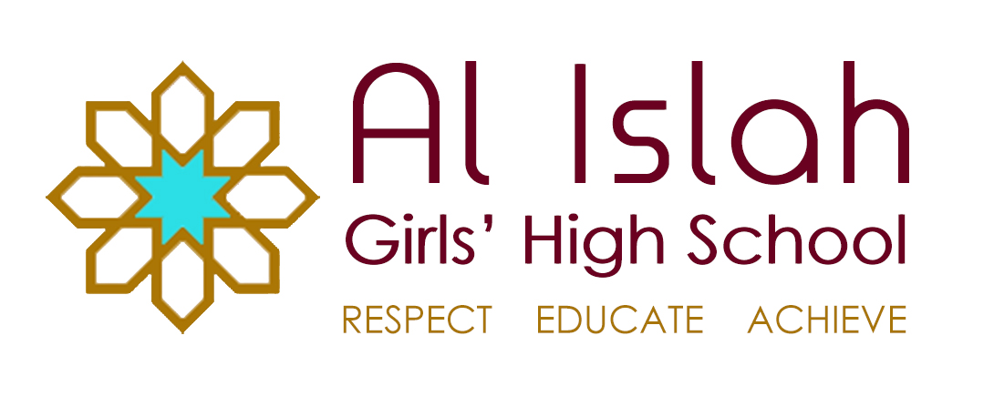
We are always open to new suggestions so if you do have any further ideas for information to be included within the booklet please don’t hesitate to get in touch by e-mailing the school via head@alislah.org.uk

