YEAR 7
SAMPLE PAPER
ENGLISH READING - PAPER 1
READING BOOKLET + ANSWER BOOKLET
60 MINUTES
PLEASE DO NOT TURN OVER THE PAGE UNTIL INSTRUCTED

Reading Booklet
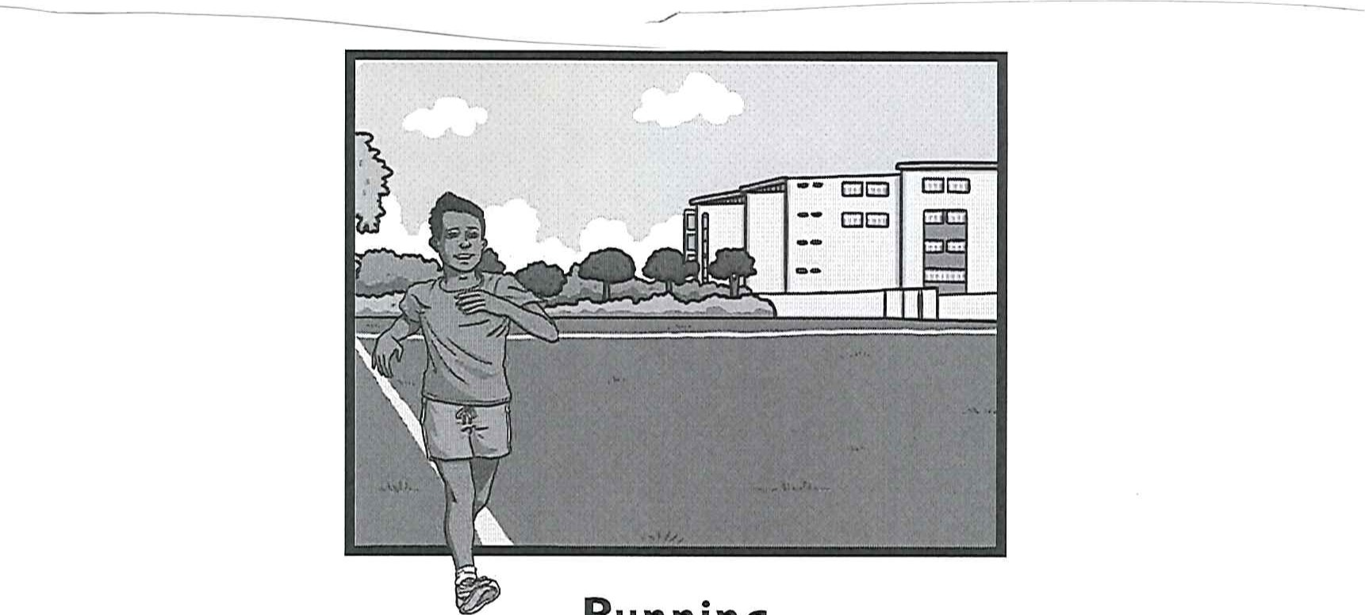
Running
Leisure

The Dual World of Anders Arnfield
Contents
Running | pages 3—5
Leisure | page 6
The Dual World of Anders Arnfield | pages 7-9

o

Introduction
Running is free, you can do it almost anywhere and it has many potential health benefits. Suitable for adults and children, it can improve your fitness, reduce your risk of illness and help to maintain a healthy active lifestyle. It's no wonder an estimated six million people in the UK are now going jogging at least once a week.
Beginner's Guide
If you've never been a runner and are thinking oj giving it a try, there are a few useful tips for beginners. It is always a good idea to build your fitness gradually. The key is consistency and a slow increase in speed and distance. Try to run regularly - a few times per week — but there's no need to go too far or too fast straight away.
Begin each run with a gentle warm-up for at least five minutes.
- If you're totally new to running, start by walking for any amount that feels comfortable from about 10 to 30 minutes.
- When you can walk comfortably for at least 30 minutes, include some short running Intervals of one or two minutes.
- As time goes on, make the running intervals longer and the walking sections shorter until you're just running the whole way!
- Keep an upright posture, smooth stride and aim to have your arms and shoulder relaxed with elbows bent.
- Always give yourself time to cool down properly when you finish a run by walking and gently stretching for at least 5-10 minutes.

Staying Motivated
Goals - Set yourself regular targets of either time, frequency or distance. You don't need to be involved in a race to be in competition. Sometimes, competing with yourself can be just as much of an exciting challenge.
Clubs and Company - Run with a friend or local group. Most clubs cater for all ages and ability levels, including beginners, and are usually a very friendly bunch. According to research, you're more likely to stick with regular exercise if It's a sociable activity that you do with someone else.
Diary - Keep a training log of your runs. This could include as much or as little detail as you like. You could note your route, distance, time and how you felt. If you ever feel like you're not making as much progress as you wanted, look back over your past achievements!
Variety — mix up your routes and distances to avoid the same old routine becoming boring. Doing other forms of exercise is known as cross-training. Swimming and cycling are other great ideas to support and Improve your running, as well as being enjoyable exercise too.
Different Distances and Types
Track Running | Usually Involves athletes running over specified distances on an oval running track. Events are generally categorised as sprints, middle distance and long distance, plus hurdles races.
Road Running | Anyone can enjoy road running and even compete In events with measured courses over an established distance. This could be running safely along pavements or In an organised events roads may have special permission to be closed to all vehicle traffic. These events normally start at 5km or 10km, ranging up to half marathons (13.1 miles) and marathons (26.2 miles).
Cross Country Running | Also similar to Fell running or Trail running — this usually takes place over open or rough terrain which may include grass, mud, woodlands, hills or even water.

Specialist Gear and Gadgets
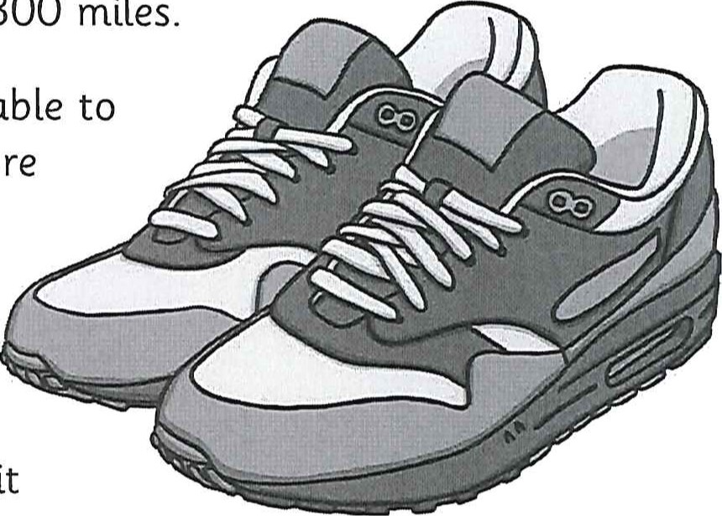
Running doesn't have to require much equipment but a good pair of running shoes are an essential investment in order to reduce the risk of injury. Specialist running retailers can give advice and fit running shoes to individual runners, based on your ability and goals. Running shoes should fit snugly to avoid slipping and sliding that can lead to blisters. A good design allows your foot to strike the ground properly, reducing the amount of shock that travels up your leg. They should be replaced over time, typically every 300 miles.
When you get started, you can wear whatever feels comfortable to run in. After a while, you may choose some clothing with more technical sports fabric, which is designed to draw the sweat away from your body.
As your running advances, you may decide to use a digital sports watch to record and monitor your runs or even a heart-rate monitor to check your effort level is where it should be.
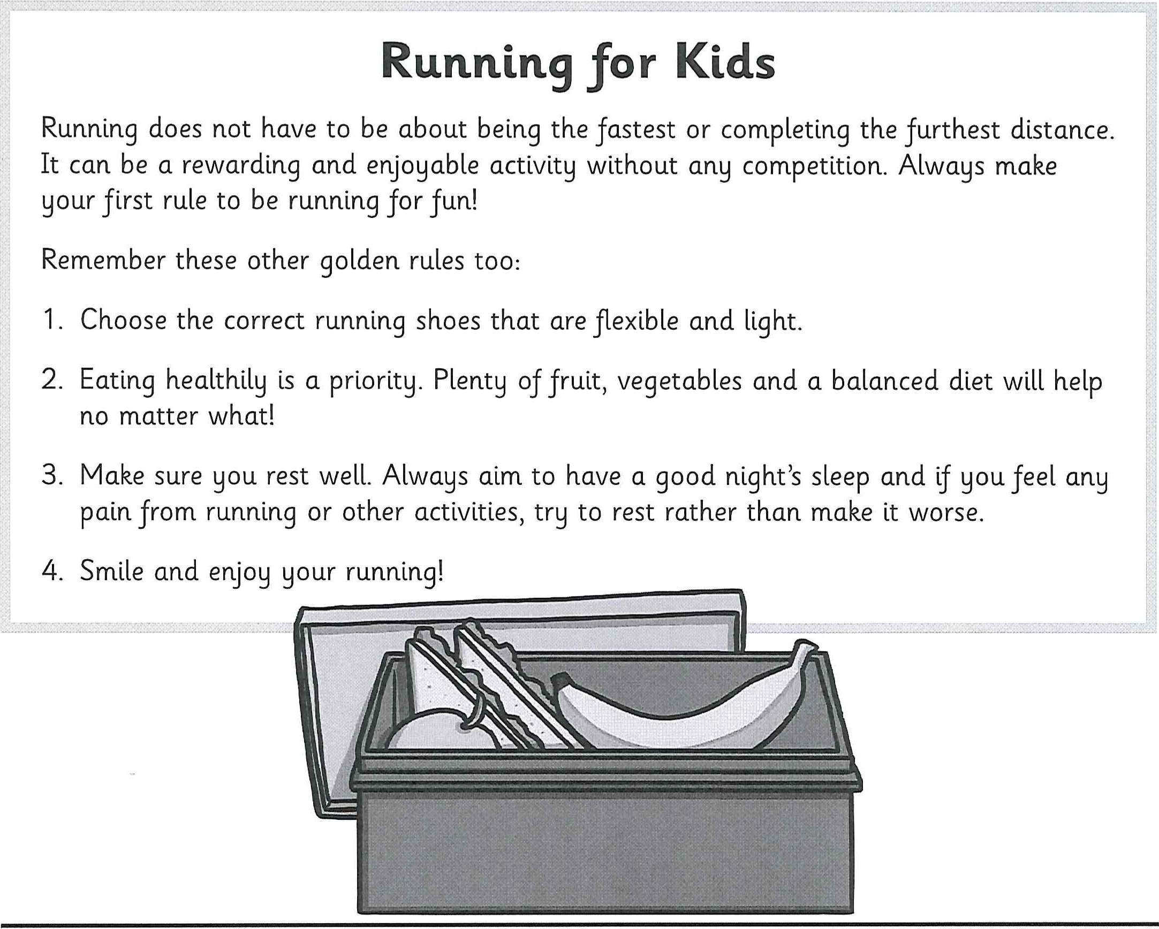

e

Leisur
What is this life if, full of care,
We have no time to stand and stare.
No time to stand beneath the boughs And stare as long as sheep or cows.
No time to see, when woods we pass,
Where squirrels hide their nuts in grass.
No time to see, in broad daylight,
Streams full of stars, like skies at night.
No time to turn at Beauty's glance,
And watch her feet, how they can dance.
No time to wait till her mouth can Enrich that smile her eyes began.
A poor life this is, full of care,
We have no time to stand and stare.
By William Henry Davies (1871-1940)

The Dual World of Anders Arnfield
This is an extract from afantasy story about a young boy who lives in another world during his dreams. His experiences there are influenced by his ordinary waking life and the clues of his dream world guide his actions in the normal life he leads during his daytime reality.
Fuelled by rage and revenge, Anders Arnjteld stood in front of the giant gates of Pengreg Hall and raised his sword to face the snarling creature ahead. In front of him and for miles beyond lay the ruins of the ancient Gunders Wood, smouldering in ashes as the once tall trees lay forlorn on the forest floor. Behind the great house, over his shoulder, he could sense the path to freedom but he was determined not to take the easy way out.
There was no doubt in Anders' mind that the creature bearing down on him was the same Klingenot he had encountered In his previous dreams; a creature he had so often doubted could be real. It sure looked real right now as he found himself not only the prey to this huge jour-legged beast, but with the sole responsibility to defeat it. Over many months, he had become used to the dual worlds that he had gradually found himself living In: by night, the strange and mysterious happenings of Gunders Wood, overlooked by the marvellous Pengreg Hall; by day trying to fathom how those happenings linked and influenced his ordinary schoolboy life.
Casting his mind back two years, the young boy thought of the precious box given to him by his late grandmother before she returned to Norway. How he wished she had still been alive to answer his millions of questions. Was there a vital clue in the box that he was missing right now? Every part of the contents had turned out to be a clue to something or other. Some days he cursed the gift that his grandmother had given him: not the gift of the box though; the gift she had passed down In some other way. As often as he may curse it however, he couldn't imagine life any different to the way it had become.
Unfortunately, he had little time to ponder the many burning questions. All that imminently mattered was how to hold off the baying beast ahead. With its arched stegosaurus-like spine and flaring dragon-like nostrils, the Klingenot was close enough
for Anders to smell its stale breath. He told himself that the creature must represent something or someone in the real world — that's how everything had been so far in all oj Anders' adventures around Gunders Wood. Although he was furious to see the destruction oj the once beautiful woodland he had grown to love, Anders could see that the creature in front of him was angry too.
As if glowing brightly Ilke a neon sign, the word 'angry' burned Into his mind, his consciousness, but it did not feel complete. The word itself was missing something. The creature was not just angry; it was hangry. As always, the word didn't make any sense to Anders. Whilst holding the gaze of the bulging eyes and writhing head, he desperately tried to make time for himself to think, simultaneously tossing the words around. Angry. Hangry. Hungry. Finally, the realisation began to emerge. Anders' mind felt as foggy as the thick air that hung over the rough, open landscape around him — the two things were almost certainly linked — but he felt a certainty that he was on the verge of solving something. Like a clearing in the mist, he could see the swirls of an explanation forming through his muddled mind. Hangry: the creature's anger was driven by hunger.
Previous visions flashed into his brain featuring contented Klingenots roaming peacefully (n pairs through the surroundings oj Gunders Wood. In every image, they were eating the leaves and foliage from the branches. Creatures of other varied shapes and sizes wandered amongst them, unharmed and in no anticipation of any danger. Anders had felt these images before — not necessarily been there, but felt them. Only snapshots and sections of this wonderful world had been revealed to htm but he recognised some of the unusual beings that lurked around both then and now. There were the squibs (that reminded him of jellyfish but shuffled around awkwardly on land) and the belchers (easily identified by their burping, gurgling sound). As wonderful as these creatures were and as privileged as Anders felt to frequent their world, right now, they didn't all absorb his focus. The important part of the images flickering past him were definitely the Klingenots and most importantly of all, he was drawn to the way they lifted their old-looking heads and plucked their food purposefully from the trees.
It was hard enough for a normal person to try to make sense of a dream after they had woken up, let alone trying to figure out disguised meanings and messages whilst you're still immersed in amongst them. Yet thoughts and reasoning seemed
to be falling into place. Anger would only fuel more anger. Instinctively, the boy knew that he had to put down his sword. As he did so, the roar of the creature distorted in pitch and volume, changing into a groan. Anders still felt vulnerable. Overwhelmingly aware that he was not yet safe, he could just distract the beast momentarily then he might get a chance In the waking world to influence what happened next.
Turning tentatively to the right, Anders focused all his energy onto the misty window at the far end of the hall's front. Once before, he had been able to pull off something like this but the effort and concentration was so great right now that he felt a knot forming in his forehead. Could he do It? Through the strain came a single quiet tap. It was working. Tap, tap — louder. Squeezing his eyes tightly shut, he willed his thoughts all into the single direction. Tap, tap, tap. The noise he was creating on the window was suddenly enough to gain the attention of the Klingenot. In an instant, the beast's large pointed ears twitched and rotated; it swung its head to the left and narrowed its eyes to focus on the far window. Anders knew this was his chance and he seized it.
By Steve Johnson

Felsted
YEAR 7
SAMPLE PAPER

READING ASSESSMENT
ANSWER BOOKLET
NAME:

SCHOOL:

total marks
Year 6 Reading Assessment Non-Fiction
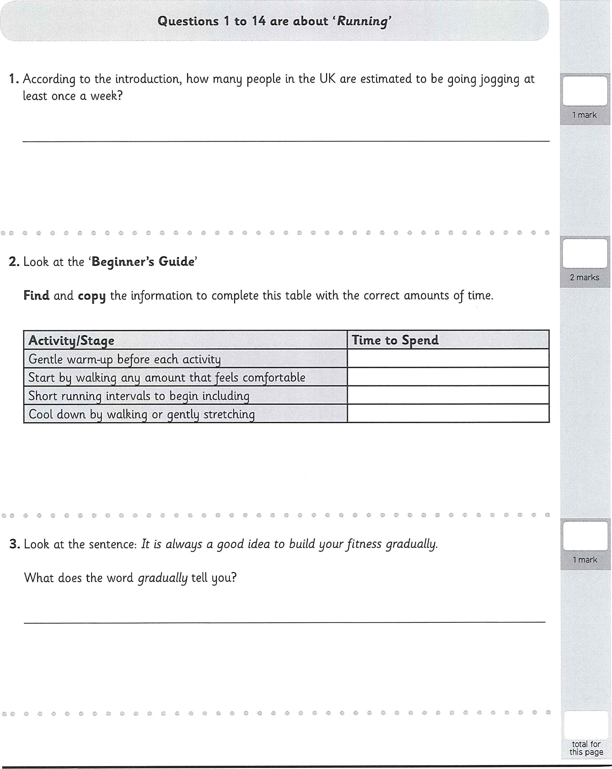
- Look at the 'Beginner's Guide'
Find and copy the information to complete this table with the correct amounts of time.
O o
- Look at the sentence: It is always a good idea to build your fitness gradually.
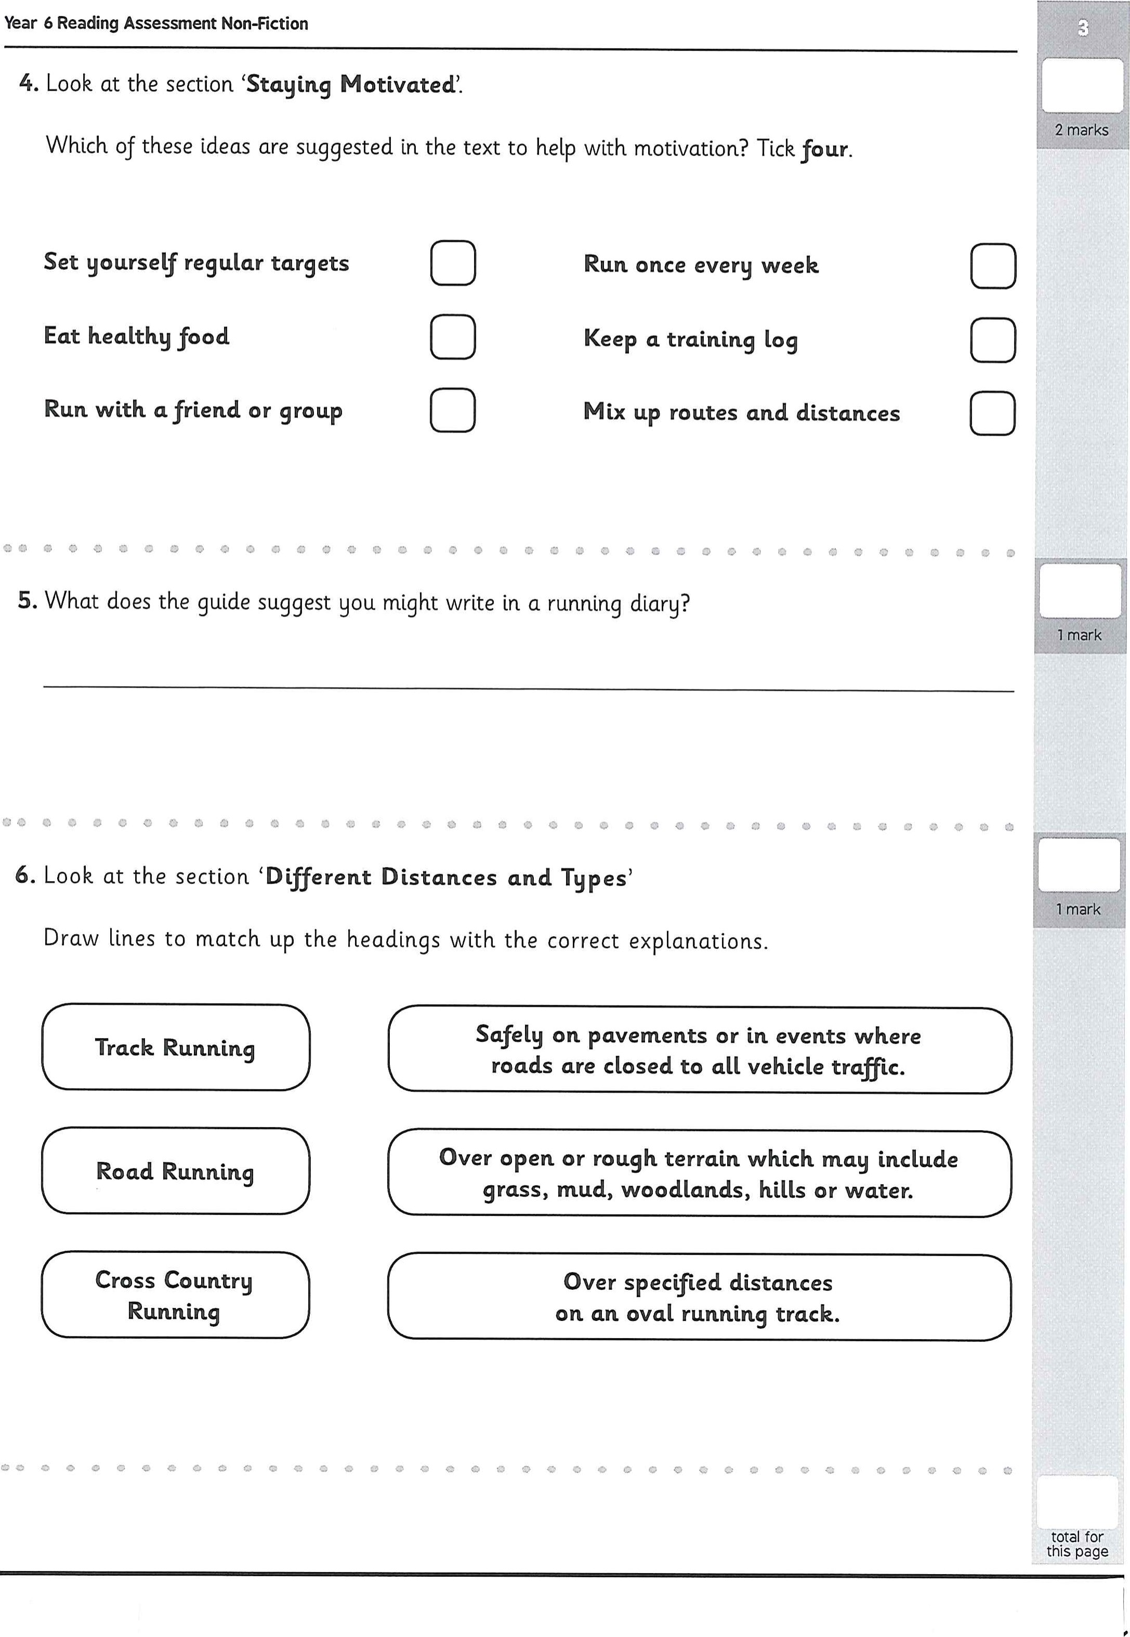
with motivation? Tick four.
Set yourself regular targets Run once every week
Eat healthy food Keep a training log
Run with a friend or group Mix up routes and distances
- What does the guide suggest you might write in a running diary?
- Look at the section 'Different Distances and Types'

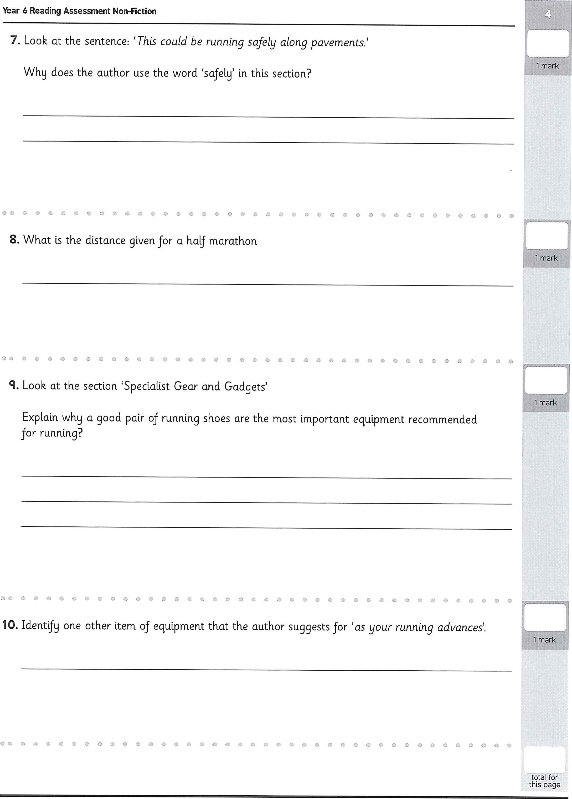
- sentence: {This could be running safely along pavements.'
Why does the author use the word 'safely' in this section?
- What is the distance given for a half marathon
q. Look at the section 'Specialist Gear and Gadgets'
- Identify one other item of equipment that the author suggests for 'as your running advances'.
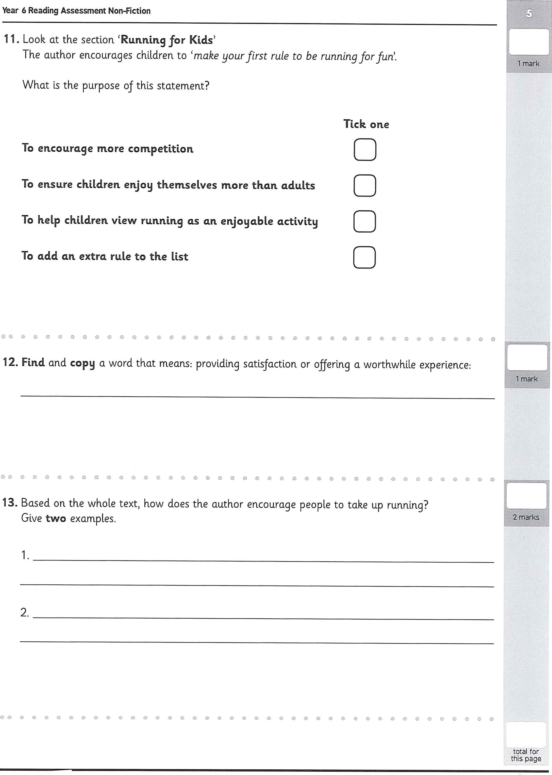
- section 'Running for Kids'
The author encourages children to 'make yourfirst rule to be running for fun'.
What ts the purpose of this statement?
Tick one
To encourage more competition
To ensure children enjoy themselves more than adults
To help children view running as an enjoyable activity
To add an extra rule to the list
- Find and copy Q word that means: providing satisfaction or offering a worthwhile experience:
- Based on the whole text, how does the author encourage people to take up running? Give two examples.

Year 6 Reading Assessment Poetry

12 total marks
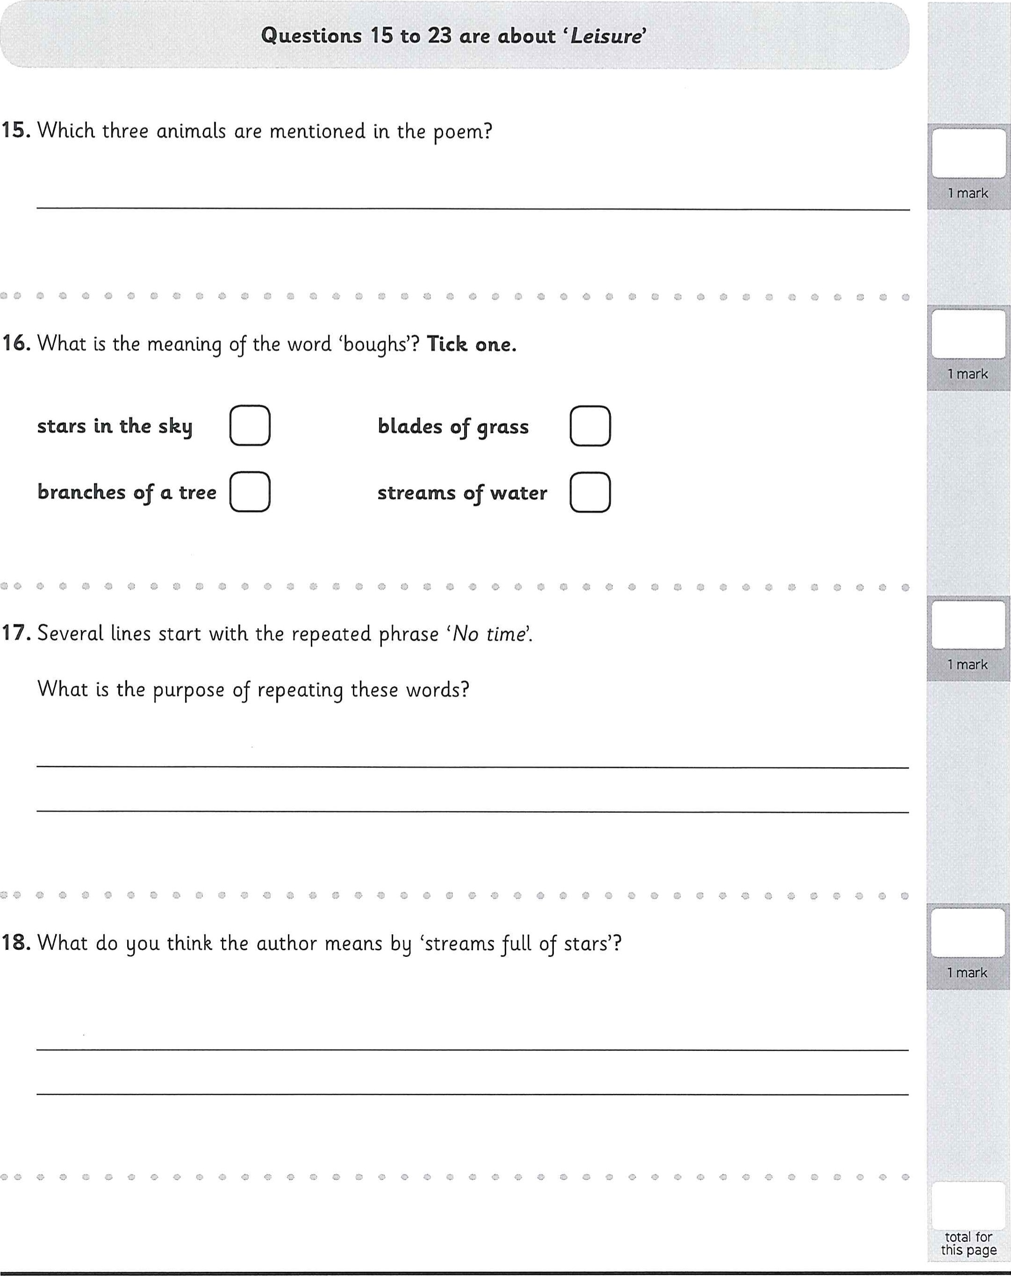
- Which three animals are mentioned in the poem?
o
- What is the meaning of the word (boughs'? Tick one.
stars in the sky blades of grass
branches of a tree streams of water
e o
- Several lines start with the repeated phrase 'No time'.
Year 6 Reading Assessment Poetry

- Find and copy a phrase which could mean 'too occupied with worry'.

00
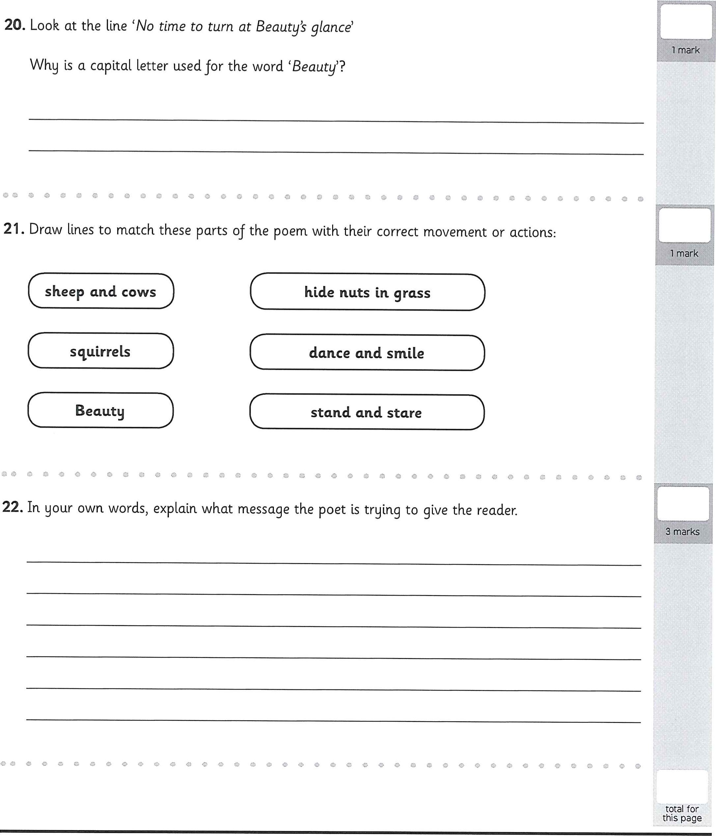
- Look at the line 'No time to turn at Beauty's glance'
1 mark
Why is a capital letter used for the word 'Beauty'?
- Draw lines to match these parts of the poem with their correct movement or actions:
sheep and cows
- In your own words, explain what message the poet is trying to give the reader.
total marks

Year 6 Reading Assessment Fiction

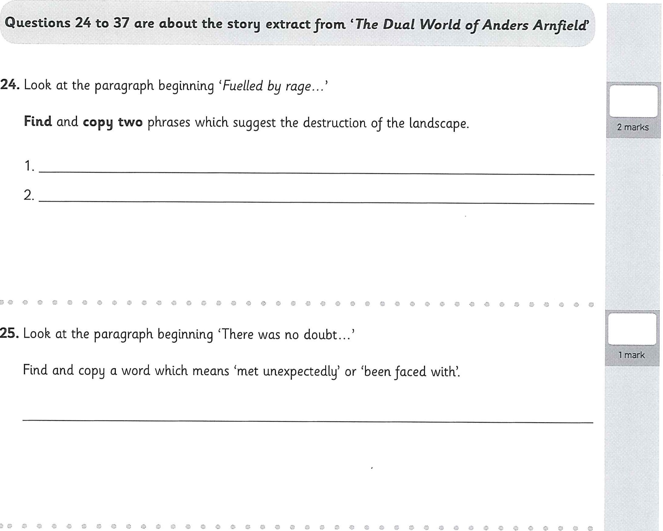
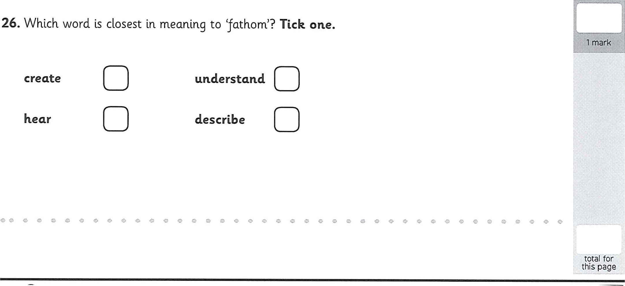
- Which word is closest in meaning to 'fathom'? Tick one.
create understand
hear

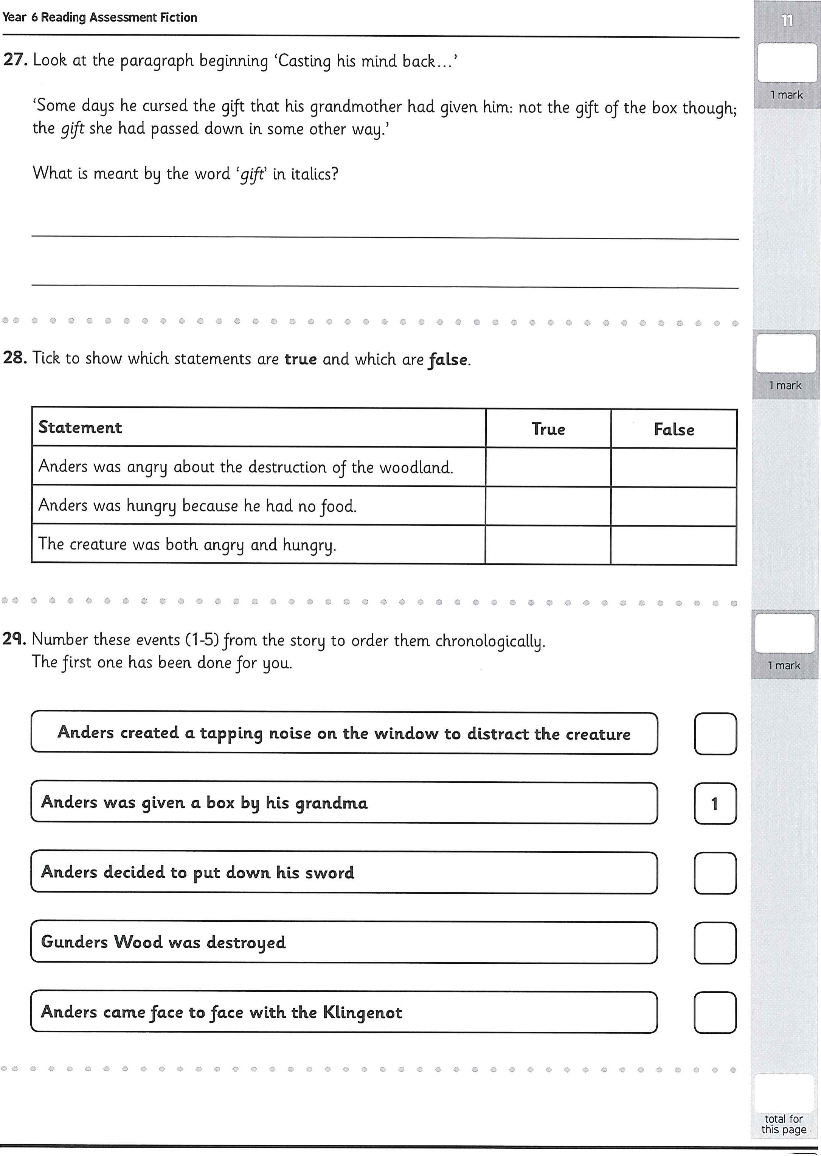
- Look at the paragraph beginning 'Casting his mind back.
'Some days he cursed the gift that his grandmother had given him: not the gift of the box though; the gift she had passed down in some other way.'
What is meant by the word 'gift' in italics?
- Tick to show which statements are true and which are false.
C O o o
- Number these events (1-5) from the story to order them chronologically. The first one has been done for you.
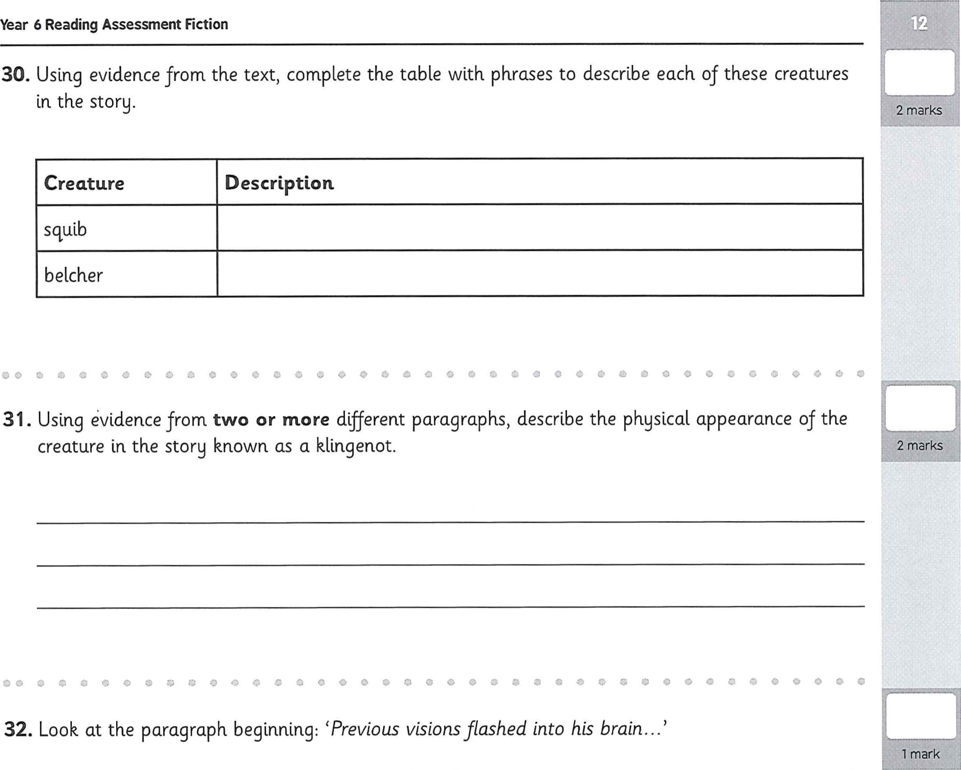
in the story.
creature in the story known as a klingenot.
33. 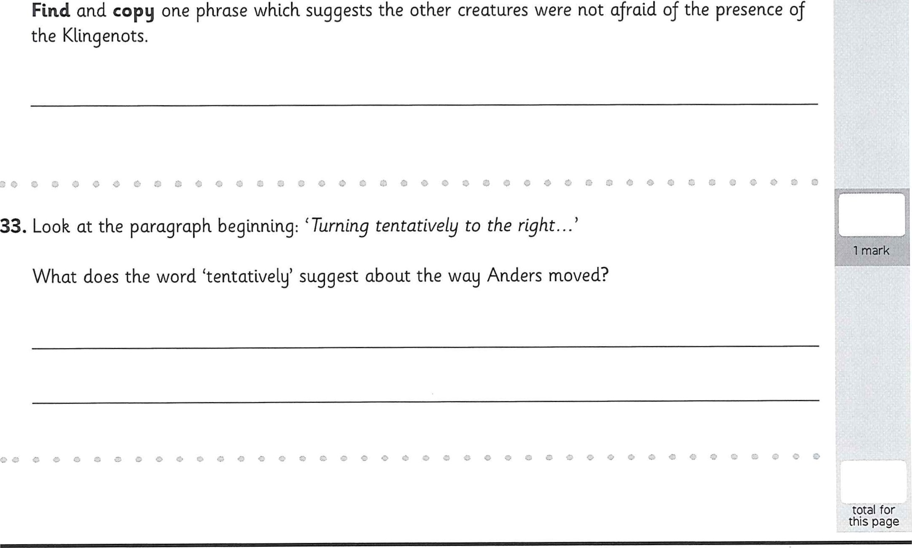Look at the paragraph beginning: 'Turning tentatively to the right..
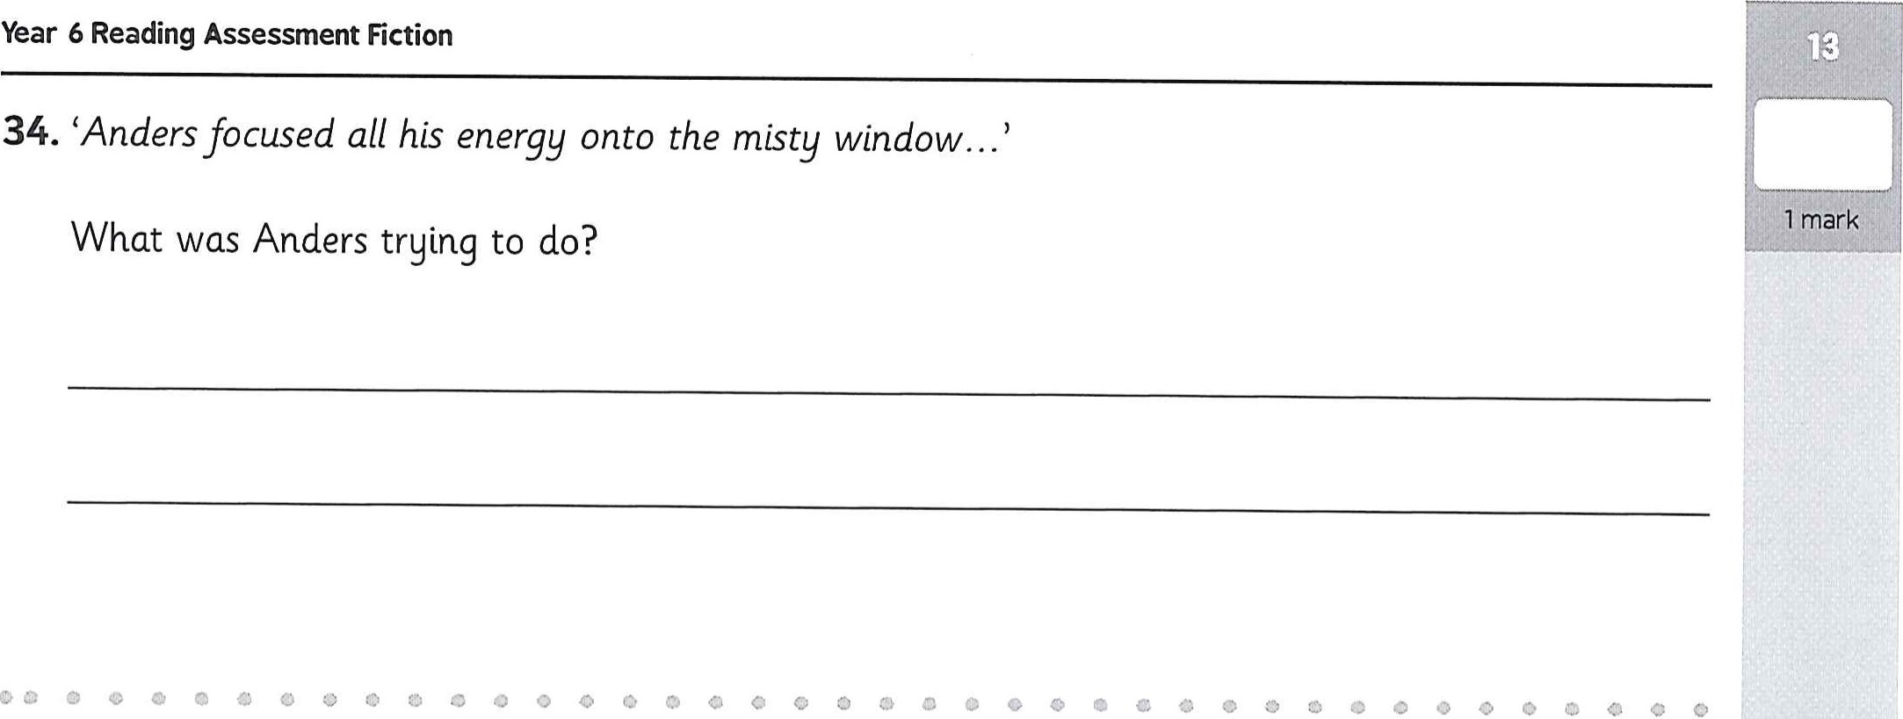
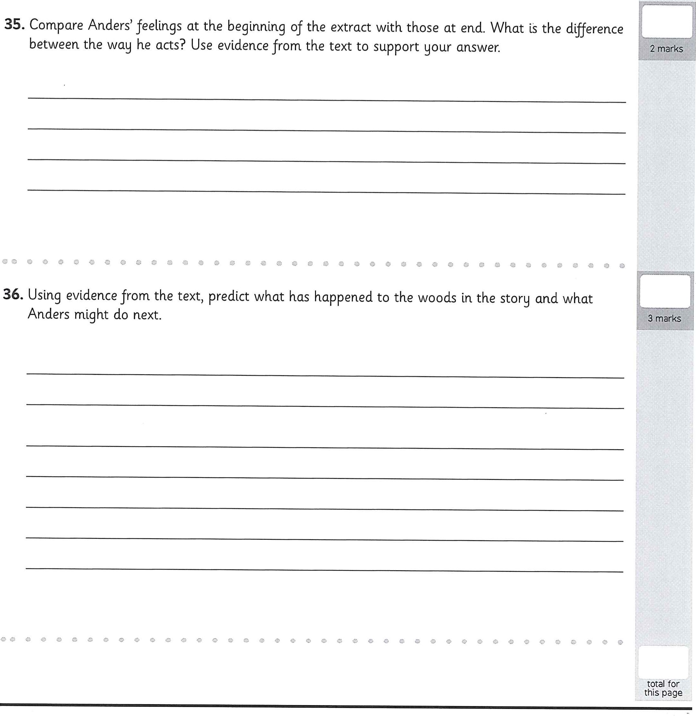
- Compare Anders' feelings at the beginning of the extract with those at end. What is the difference between the way he acts? Use evidence from the text to support your answer.
- Using evidence from the text, predict what has happened to the woods In the story and what Anders might do next.

2 marks
- How do you think Anders feels about his surroundings tn the extract? Give two feelings, with evidence from the text to support your answer.

